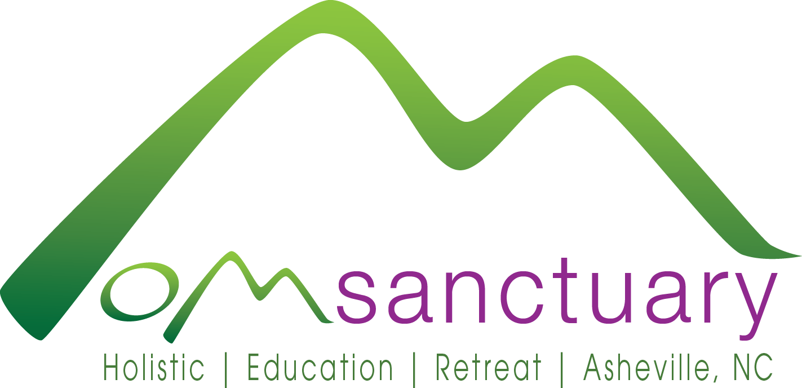
OM Sanctuary - Holistic Education Retreat
87 Richmond Hill Dr • Asheville, NC 28806 • Phone: 828.252.7313 • Website: omsanctuary.org
Press Release
For Immediate Release Contact: Shelli Stanback
May 28, 2015 828-252-7313
Email: shelli@omsanctuary.org

Human Health and Connection with Nature
An educational event and celebration hosted by OM Sanctuary

Asheville, NC – On Saturday, June 6, Oshun Mountain (OM) Sanctuary in Asheville, NC will host an open house and conservation celebration with an informative hike through a recently protected urban forest overlooking the French Broad River. OM Sanctuary will welcome visitors between 11 am and 4 pm, offering free lectures, class demonstrations, an educational hike, and raffle/silent auction centered on the theme ‘Human Health and Connection with Nature.’ Founded in 2012, OM Sanctuary is a non-profit holistic education and nature-sensitive retreat center that offers overnight stays, classes, lectures, trainings and other programs.
“Nature is integral to our well-being — you can’t separate people from their environment,” says Shelli Stanback, OM Sanctuary Founder and President. “We are pleased to offer this event as a way to learn more about OM Sanctuary and what we offer, and to explore the connection between mind, body, spirit, and nature in relation to personal health and well-being.”
The open house starts at 11 am. Holistic class demonstrations will include: Guided Relaxation and Meditation with Jerome Pearson at 11:15 am, Yoga with Elle Jai at 12:15 pm, Qi Gong for Self Healing with Lara Diaz at 1:15 pm, and Qi Gong with Virginia Rosenberg at 2:15 pm. OM Sanctuary’s Residential Chef Katie will also present Nutrition and Clean Eating demos at 12, 1, and 2 pm. At 3:15 pm, the Southern Appalachian Highlands Conservancy (SAHC) will give a brief introduction to conservation easements, followed by an educational, guided 0.6-mile walk through OM Sanctuary’s preserve.
Led by SAHC’s AmeriCorps Stewardship Associate Andrea Thompson, hikers will learn about identification of native plant species, what constitutes a healthy forest community, and the importance of biodiversity for ecosystems. As participants ruminate on the interdependence between nature and human health, they can expect to see native species such as rosebay rhododendron, mountain laurel, black walnut, American beech, American holly, Carolina silverbell, New York fern, hay-scented fern, cucumber root, striped wintergreen, and more.
After three years of dedicated effort, OM Sanctuary’s 42-acre urban forest was recently protected by a conservation easement with SAHC. Overlooking the French Broad River, Interstate 26, and Riverside drive, the easement protects a bluff containing cove forest, oak forest, and low montane pine forest with mixed hardwoods. The tract also contains pools in the river floodplain that provide likely habitat for wildlife like salamanders, amphibians and reptiles.
“Protecting the forest with a conservation easement will assist OM Sanctuary in fulfilling our mission to inspire healthy lifestyle practices through holistic education and connection with nature,” says Stanback.
The open house and celebration of the new conservation easement are open to the public, free or by donation. The event will conclude at 4 pm with a raffle drawing. Donations and proceeds from the raffle and silent auction will be used to benefit the OM Sanctuary’s mission of providing holistic health services to individuals of all of all ages, cultures, and income levels.
For more information, visit www.omsanctuary.org.
About OM Sanctuary:
This non-profit organization was formed in 2012 as a response to the increasing number of people of all ages, cultures, and income levels seeking holistic methods to improve health, reduce stress, and bring balance to their personal and professional lives. Located on the site of the historic Richmond Hill hotel just outside downtown Asheville, NC, OM Sanctuary responds to this need by offering a holistic retreat center, educational scholarship programs, and charitable initiatives focused on Body, Mind, Spirit, and Nature. Their mission is to inspire healthy lifestyle practices through holistic education and connection with nature. For more information, visit http://www.omsanctuary.org.
About Southern Appalachian Highlands Conservancy:
Since 1974, the Southern Appalachian Highlands Conservancy has protected over 68,000 acres of unique plant and animal habitat, clean water, farmland and scenic vistas of the mountains of North Carolina and Tennessee for the benefit of present and future generations. In addition to preserving land, their conservation work includes guided hikes, volunteer workdays, educational workshops, and farmland access initiatives. For more information, visit www.appalachian.org.
###

